SMART LIGHTNING WARNING SYSTEM

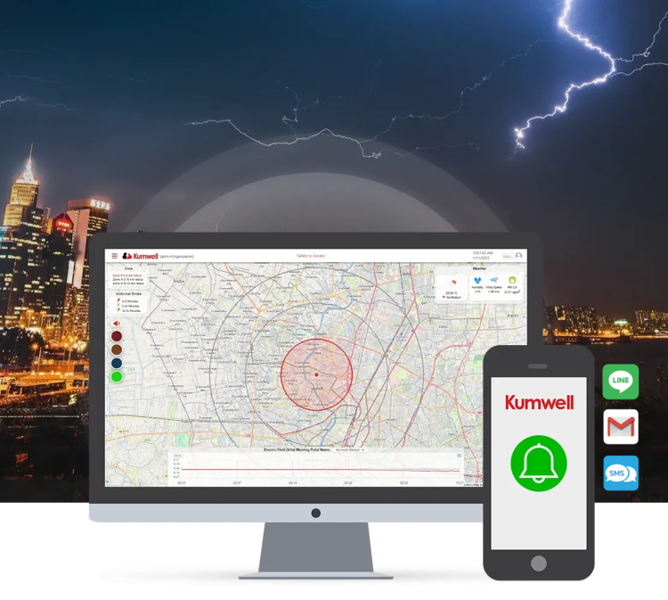
KUMWELL’s innovative ‘Smart Lightning Warning System’ is a real-time lightning detection and alert system that integrates Electric Field data (E-Field data) collected via E-field sensors with data from the Global Lightning Network. The data is processed using the Alarm Viewer Software, which is certified under the ISO 29110-4-1 Software Development standard.

The system provides visualizations of the coverage area, alert signal levels, lightning occurrence time indicators, detailed lightning information, weather data, and electric field intensity. Lightning alerts are delivered through various notification devices and communication platforms such as LINE groups, emails, and SMS, ensuring timely warnings to enhance safety and preparedness.

